2019 Dakota Woodturner’s Symposium

2019 Safety Equipment for Symposium Participants

1. safety glasses

2. face shield

3. dust masks

4. Safety conscious attitude

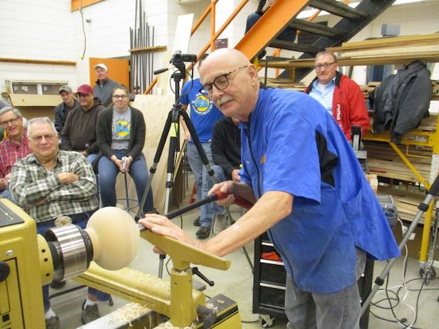

2019 Dakota Woodturner’s Symposium Tool List
Tom Wirsing
Equipment Needs, Platter Turning Class – Tom Wirsing
For Tom Wirsing’s platter turning classes, we will need the following equipment:
- A lathe for each student
- A faceplate for every lathe
- A chuck for every lathe, equipped with dovetail jaws.
  - Vicmarc chucks come standard with dovetail jaws. Any Vicmarc chuck with dovetail jaws ranging from 2 ½” in outside diameter when fully closed to 4 ¼” in outside diameter when fully closed is acceptable. For VM120 chucks, V00695, V00675, and V00676 jaws are acceptable. For VM100 chucks, V00644 jaws are acceptable
  - OneWay Stronghold and Talon chucks do not come standard with dovetail jaws. Standard OneWay “Profiled” jaws are not acceptable. However, OneWay supplies excellent dovetail jaws. For Stronghold chucks, part number 2948 #2 smooth jaws and part number 3236 #3 smooth jaws are acceptable. For Talon chucks, part number 3238 #3 smooth jaws are acceptable
  - Other brands of chucks with dovetail jaws are acceptable so long as the outside diameters of the jaws when fully closed range from 2 ½” to 4 ¼”.
- Students should bring their favorite bowl gouges, preferably in ½” or 5/8” shaft diameter. If students have scrapers, bring them. I will provide additional scrapers for students who do not have them. Students should bring a full-coverage faceshield (this is important!) and a turning smock, preferably short-sleeved.

2019 Dakota Woodturner’s Symposium Tool List
Robert Gruman

Equipment needed for Robert Gruman’s small box turning

1.Spindle gouge

2.Roughing gouge

3.Parting tool

4.Square nose scraper

5.Round nose scraper

6.Skew

7.Sand paper

8.Sliding, dial, or venier calipers

